Press release

Extension of the Württemberg State Library

System partition walls from feco-feederle

Karlsruhe, January 2021. The extension, which is set to be completed in 2020, will add approximately 7,400 square metres of usable space on six levels to the Württemberg State Library. The building, which is located opposite the New Palace in Stuttgart, was planned by the architectural office LRO Lederer Ragnarsdóttir Oei. The extension building is a separate structure connected to the old building solely by bridges and defines a new square with the reading room of the old building and the State Archives. With handcrafted formwork of rough-sawn boards the architects continued the high quality of the exposed concrete in the extension building as a reference to the old building. Following a public procurement procedure, feco-feederle was chosen as the most cost-effective supplier for the system partition walls.

The corridor walls of the offices on the first floor and parts of the ground floor meet the architects' high design standards. Continuous skylight strips with fecostruct frameless, flush structural glazing and all-round 20-mm-thin edge bonding transport daylight into the corridor areas. The solid wall, door leaf surfaces and the support frame of the fecostruct glazing are coloured white. The fecotür H70 with R _{w,P} = 37 dB and visually identical H85 with R_{w,P} = 42 dB doors have concealed frames and flush door leaves on the corridor side. Flush, lacquered wooden skirting boards are visibly screwed on.

The mounting of the feco system partition walls on pre-assembled sleeper timbers acoustically decouples the system walls. Together with the high sound insulation test value of the fecowand solid wall of R _{w,P} = 52 dB with a wall thickness of just 105 mm, excellent sound insulation of the offices is achieved, enabling communication and concentration to take place alongside each other within the sensitive library environment. The feco system partition walls therefore meet the requirements not only visually but also structurally.

www.feco.de

The feco Group creates spatial solutions that connect and inspire people.

feco Systeme GmbH
feco Systeme GmbH develops space-defining partition wall systems for high design and construction-related requirements. The company sells system components to licensed partners worldwide. Commercial-property carpenters and large interior design companies create the system partition walls according to their respective country-specific requirements. As the licensor, feco provides partners with access to a sophisticated wall system. This includes upright, glass-frame and connecting profiles, as well as static, sound and fire prevention test certificates. As a result, a large number of solid and glass wall systems are available, and these are used in the buildings of high-profile customers. The design possibilities range from solid walls with veneer or melamine surfaces, to single-pane or double-glazing glass walls.

feco-feederle GmbH
feco-feederle GmbH creates challenging projects realised with feco system partition walls and strong brand office furnishings. Thanks to its two divisions, the company is able to offer a complete spatial design service for office buildings, research and educational institutions from a single source that encompasses the project-oriented design, manufacture and installation of feco system partition walls and interior design services, as well as the design, planning and realisation of office furnishings with high-quality brands.

feco Systeme GmbH and feco-feederle GmbH are sister companies with the same shareholders.

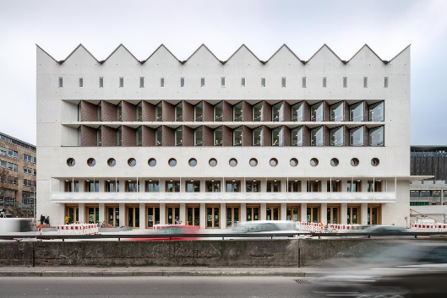
File name: NK_20_3953.jpg
Caption: Extension planned by LRO

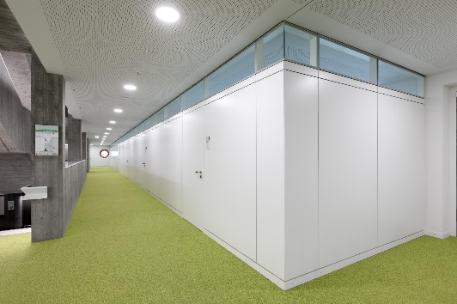
File name: NK_20_3829.jpg
Caption: Continuous fecostruct skylight

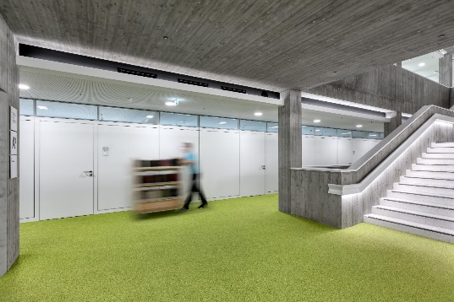
File name: NK_20_3826.jpg
Caption: Frameless, flush-fitted skylight glazing

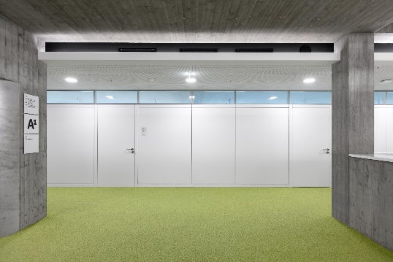
File name: NK_20_3815.jpg
Caption: Precise joints and flushness

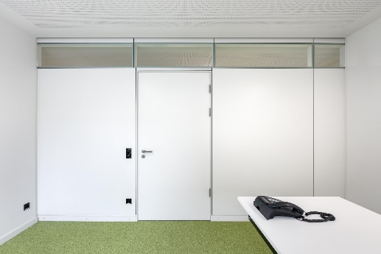
File name: NK_20_3787.jpg
Caption: Good sound insulation

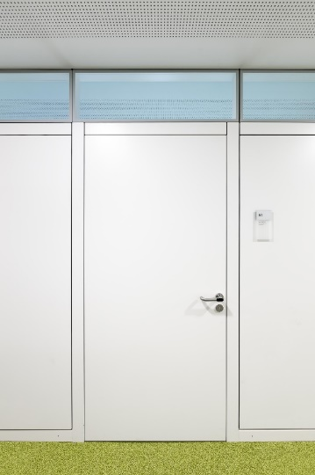
File name: NK_20_3931.jpg
Caption: Wooden door flush on the corridor side

Photographer: Nikolay Kazakov, Karlsruhe
nikolay@kazakov.de, www.kazakov.de

The photographer, Nikolay Kazakov, is to be named directly beneath the image or at another suitable location. All rights of use are held.

Reproduction free of charge / copy requested

Additional information for journalists:
feco Systeme GmbH PR-Agentur blödorn pr
Rainer Höhne Heike Blödorn
Am Storrenacker 22 Alte Weingartener Str. 44
76139 Karlsruhe 76227 Karlsruhe
Phone 0721 / 62 89-111 Phone 0721 / 9 20 46 41
E-mail: info@feco.de E-mail: bloedorn@bloedorn-pr.de

